**The App Idea**

An application that integrates communication between personal trainers and clients for organising training programs and tracking progress.

**Web:** Coaches can use the web-based app to set workout routines for their clients and track their progress by viewing analytics.

**Mobile:** Clients can see the programs assigned to them and can document what exercises they do on each day and can track their own analytics.

**Web App Pages**

**Home Page:** Coachescan see a ‘feed’ of the workout sessions that their clients have completed from newest completed workout session to oldest. This is on the left side of the screen. Each item in the feed shows the readiness score that a user has inputted, the time a user spent doing the workout session, the intensity of the session that the user has recorded, and the total weight the user has lifted in their session. The right side of the screen will be a section saying ‘Needs Programming’ that will be populated with clients that don’t have any scheduled programs for the following week, where the coach can click on them to access the clients calendar.

**Athletes Page:** Coaches can view all of their athletes here, where it will be presented in a card-like view. Each card has the client’s image in a circle in the top left corner, followed by their name. Under that is information storing their email, number, age, goals, and medical conditions. Beyond that are the actions the coach can take with that athlete (each action is accessed by clicking their icon) – calendar, analytics, and chat. The calendar icon takes them to the calendar page for that client, analytics to the analytics page for that client, and chat to the chat page for the client. In the top left, coaches can search for specific clients, and the top right, coaches can invite new clients to join them. If there are no clients, coaches are presented with a screen that says invite athletes.

**Calendar Pages:** Each client has their own dedicated calendar page which is essentially a calendar that coaches can access to populate workout sessions on each day. This view shows the workout session planned for each specific date, and coaches can also click the ‘edit’ button by hovering over each day to add/change a workout session. At the top of the page is a drop-down box with client names that users (coaches) can click to change the page to a different client.

**Workout Sessions Page:** After coaches click into the workout session for each day, they can fill out information to setup the workout for the specific date. At the top, coaches can navigate back to the calendar for that client. From there is information displaying the date. In line with this is a button to save the session, and a button to delete the session and start over. Underneath is a button for generating a workout program with AI. In here coaches can add new exercises from the exercise library for the client to complete. They can assign how many sets, reps, and what weight they should complete it at. They can also add any notes about the specific exercise that they may want the client to read. The sets, reps, and weight at each set is set up in a tabular format for the coach to adjust to the right of the exercise name and notes section. Saving the workout session adds the workout to the date. On the left side of this page is a mini calendar to navigate to a different day, and a session preview that displays the exercises in a session based on what information the coach has setup so far.

**Analytics Page:** Coaches can view how their clients are progressing in this page. This is unique for each client. The first card tracks the client’s readiness scores, displaying the sleep, mood, energy, stress, and soreness metrics, and whether it is higher, the same, or lower on average. This is measured against their long-term average (last 6 months) and is based on the last 14 days. The numbers for the overall long-term average (last 6 months for the average of all metrics to calculate total readiness score) and recent average (last 14 days for the average of all metrics to calculate total readiness score). The next card tracks the total volume lifted of weight each day in the given date period. This is presented in a column graph, showing the weight on the left-hand side, and dates across the bottom (but these dates are hidden only the first and last dates are shown). At the top of the page, coaches can change the client that they are looking at through the same drop-down box in the calendar page, and they can adjust the date range for the data being shown to them.

**Chat Page:** Coaches and clients can communicate with each other through chats. This is a generic chat page, where different chats are displayed in a column on the left, where the coach can search for a client’s name. If a client’s name is clicked on, then the right side is the chat with all the messages between the coach and that client.

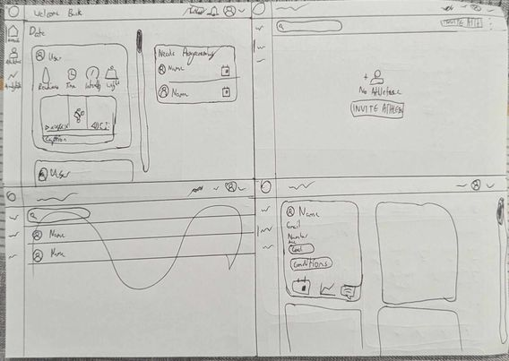

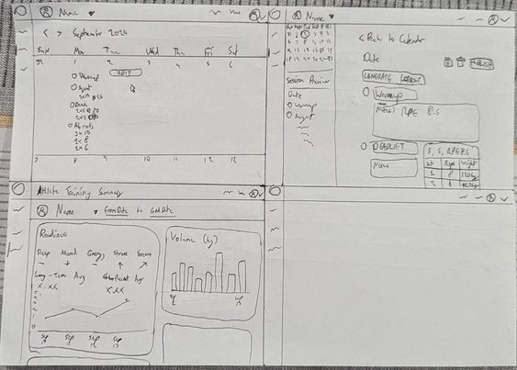

**High-Level Requirements**

* User Authentication
* Client Management
* Workout Program Creation
* Exercise Library:
* Progress Tracking and Analytics:
* GenAI-Based Workout Plan Generation:

**Database Integration**

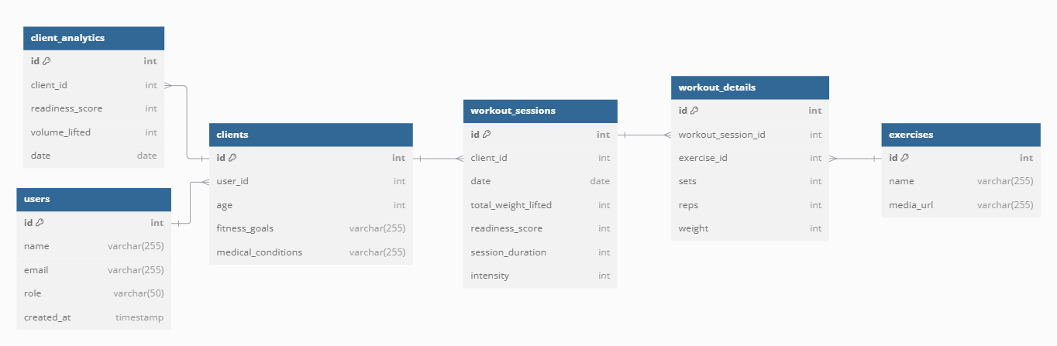

**Colours (PLACEHOLDERS – PICK BETTER FONTS AND COLOURS LATER):**F2AE30

C0C0BF

CCCCCC

D9D9D9

1E1E1E

**Approach:**

* **DONE: Setup placeholder pages**
* **DONE: Identify components and setup placeholder components**
* **DONE: Design DB and connect it with PostgREST API**
* **DONE: Setup Assets**
* **DONE: Create Header and Sidebar for each page?**
* Implement functionality in Athletes Page as most pages rely on information from clients table
  + Implement components within this (table)
  + Should be able to invite/add clients
  + Should be able to filter clients with search functionality
* Implement functionality of Calendar Pages
  + Should be able to edit each date with workout session
  + Should read information from workout session locked within this date
* Implement functionality of Workout Session Pages
  + Should be able to add workouts to the specific date for the specific user
  + Need to track each exercise with sets/reps/weight
  + Need to be able to add exercises from exercises library
  + Should be able to use GenAI to make a workout session
  + Should be able to change date being edited via mini calendar
  + Should show preview of the workout session for the day selected
* Implement functionality of Home Page
  + Should display a feed of workouts from the clients under the coach
    - This can include multimedia information (video of workout)
  + On the right side, should display any client of the coaches that needs to have workouts added (notification system)
* Implement functionality of analytics page
  + Not completely sure what I want in here yet
  + Readiness analytics comparative of the recent avg to the long term avg
  + Total volume of weight in each session in column graph

**Questions/Concerns/Issues:**

* Should I bother adding photos into my database, such as user profile pictures?
* Should the coach be able to add a new user entirely? Or should I set it up so that a coach can only add a user if they exist in the system based on email address (requiring them to sign up from the mobile app)?
* Should the search bar search as it is updated, or should I require the user to click the search button to filter results?